A000-Eur-Czech Republic-Moravia-Figurine-Ursus spelaeus (Cave Bear)-Ceramic-Dolní Věstonice-29-25 kya

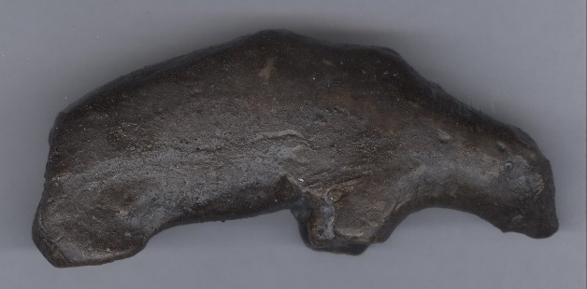

**Fig. 1.** Eur-Czech Republic-Moravia-Figurine-Ursus spelaeus (Cave Bear)-Ceramic-Dolní Věstonice-29,000–25,000 BP, right side**; Fig. 2. Same, left side.**

**Case No.: 1**

**Display description: This burnt clay depiction of a cave bear provides the inexperienced hunter with the pose necessary for an approach to the prey. The animal is obviously feeding on the ground and is oblivious to the approaching danger.**

**Accession Number:**

**LC Classification:** GN772.2.A8

**Date or Time Horizon:** 29,000–25,000 BP

**Geographical Area:** Moravia, Czech Republic   
**Cultural Affiliation:** Gravettian industry

**Medium:** fired clay at low temperature, 1300 F, or 700 C.  
**Dimensions:**  H 11.1 cm, 4.4 in: W 4.3 cm,1.7 in.

**Weight: original, unknown.**

**Condition: museum replica in resin.**

**Discussion: This type of figurine, which has not been fragmented by the kilns offers an objective counterpart to the proposed spiritual aspect of fragmentation that was apparent on most of the so-called “Venus” figurines at** Dolní Věstonice**.**

**References:**

Jelinek, J. 1975. *The Pictorial Encyclopedia of the Evolution of Man*. London: Hamlyn

Powers, R. 1994. "The Human Form in Palaeolithic Art," *Modern Geology*, 19(2-4), Switzerland: Gordon and Breach.

Rau, S., D. Naumann, M. Barth, Y. Mühleis, C. Bleckmann. 2009. *Eiszeit: Kunst und Kultur*. Stuttgart: Thorbecke Verlag der Schwabenverlag AG.

### Svoboda, Jiri and Ofer Bar-Yosef. 2003. Stránská skála : origins of the Upper Paleolithic in the Brno Basin, Moravia, Czech Republic. Cambridge, MA: Peabody Museum of Archaeology and Ethnology, Harvard University.

Velde, B. and I. Druc. 2012: *Archaeological Ceramic Materials: Origin and Utilization*. London: Springer.